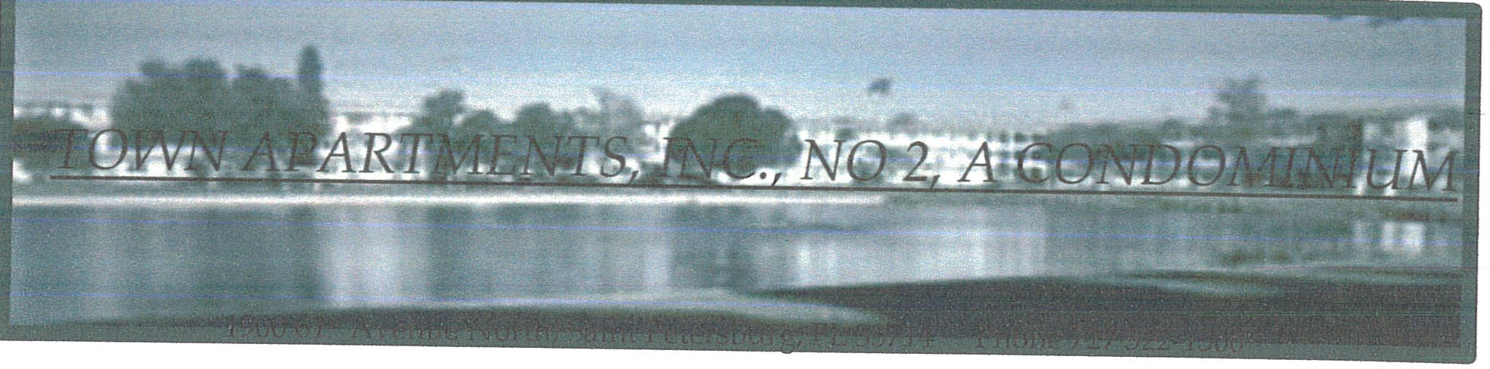
ASSOCIATION 2

DIRECTORS MEETING

NOTICE IS HEREBY GIVEN, in accordance with the Bylaws of the Association and Florida's Condominium Act, that a meeting will be held at the following date, time and place:

Date: July 9th, 2026

Time: 3:30 pm

Place: Clubhouse (Small Meeting Room) Town Apartments
1900 61st Ave N
St Petersburg, FL 33714

TOWN APARTMENTS INC, ASSOCIATION 2
By:� W.�
Presidt

AGENDA
FOR DIRECTORS MEETING JULY 9, 2026

Meeting called to order Identify attendees Presidents report Treasurers report
Approve minutes from previous meeting Address any old business
Present new business
Tent buildings due to roaches and termites Delinquent maintenance/fine payments
Rule violations and any action needed to be taken Disposition of CDs
Review Financial Statement Open discussion
Adjourn meeting

TOWN APARTMENTS INC, ASSOCIATION 2
WaM

By:�
Presi t

TOWN APARTMENTS INC, NO. 2

A Corporation NOT-for-Profit

PROOF OF NOTICE AFFIDAVIT STATE OF FLORIDA
COUNTY OF PINELLAS

The undersigned Association Board Member, being first duly appointed, deposes and says that notice and agenda for the July 9th, 2025 Directors Meeting was posted on Association bulletin boards and provided to our main office to file and post on the Association website on June 26th, 2026. This is done in accordance with the requirements of section 718.112(2)(d), FS.

Dated this: 1'� -Ile_, 25 i.b ?,,D2b
By:,A.-ef OaN,k.e_
Title: A=>sue.,. Pu�:Je�.,\--

