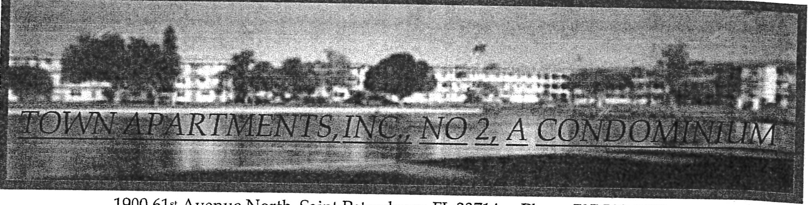
1900 61st Avenue North, Saint Petersburg, FL 33714 Phone 727 522-1500

ASSOCIATION 2

SEPTEMBER 28th, 2026 FINE MEETING

NOTICE IS HEREBY GIVEN, in accordance with the Bylaws of the Association and Florida's Condominium Act, that a Fine meeting will be held at the following date, time and place:

Date: September 28th, 2026

Time: 6:00 pm

Place: Clubhouse (Small Meeting Room) Town Apartments Inc.
1900 61st Ave N.
St Petersburg, FL 33714

TOWN APARTMENTS INC, ASSOCIATION 2
By; �1j D�k
Presid t

AGENDA
FOR THE FINE MEETING SEPTEMBER 28TH' 2026
- Meeting called to order
- Identify attendees and designate roles
- Briefly cover how the meeting will be conducted
- 5 minutes made available to discuss each violation by a Board member
- 5 minutes made available to rebut each violation
- Fine Committee will adjourn to decide if the violation(s) are valid
- A member of the Fine Committee will present findings to the attendees
- Final instructions will be given as needed
- Meeting adjourned

TOWN APARTMENTS INC. ASSOCIATION 2
w�

By:� Presid t

A Corporation NOT-for-Profit

PROOF OF NOTICE AFFIDAVIT

STATE OF FLORIDA COUNTY OF PINELLAS

The undersigned Association Board Member, being first duly appointed, deposes and says that notice of the 28 September, 2026 Fine Meeting was posted on Association bulletin boards and provided to our main office to file and post on the Association website, on 11 September, 2026. This is done in accordance with the requirements of Section 718.112 (2)(d), F.S., not later than 14 days before the meeting.

Dated this: 9 / i l /Ab 2-k
l I
By: Ag LJ��
Title: Prrz-:de(}±

April 27th, 2026 Richard De Palma 5970 21st St N #7
St. Petersburg, Fl 33714

We have learned that paint and concrete patch materials were taken from the Association's storage room without authorization. These materials belong to the Association and are for approved maintenance and repair work only.
The cost of the items removed is $116.48. Please reimburse the Association in this amount immediately.
Please note the storage room is shared and not for personal use. Removing materials without prior approval violates Association rules. Any further incidents may result in additional action as allowed by the governing documents.
If you have questions, please contact the management office.
Sincerely,
Town Apartments Inc., No. 2 Board Members (727) 522-1500
accounting@uatancondo.com Cc: UATAN Management Office

